|  |  |
| --- | --- |
|  | ***Study*** |

**Exercise 1:**

Read chapter 13 of the following book:

Learning Python:

<http://www.dsf.unica.it/~fiore/LearningPython.pdf>

Then answer the quiz in page 414

**Exercise 2:**

Implement Sorting exercise using Bubble Sort algorithm

|  |  |
| --- | --- |
| *http://www.bestappsforkids.com/wp-content/uploads/2012/04/save-turtle.png* | ***Turtle exercises*** |

Using turtle to draw the following shapes:

1. 2.

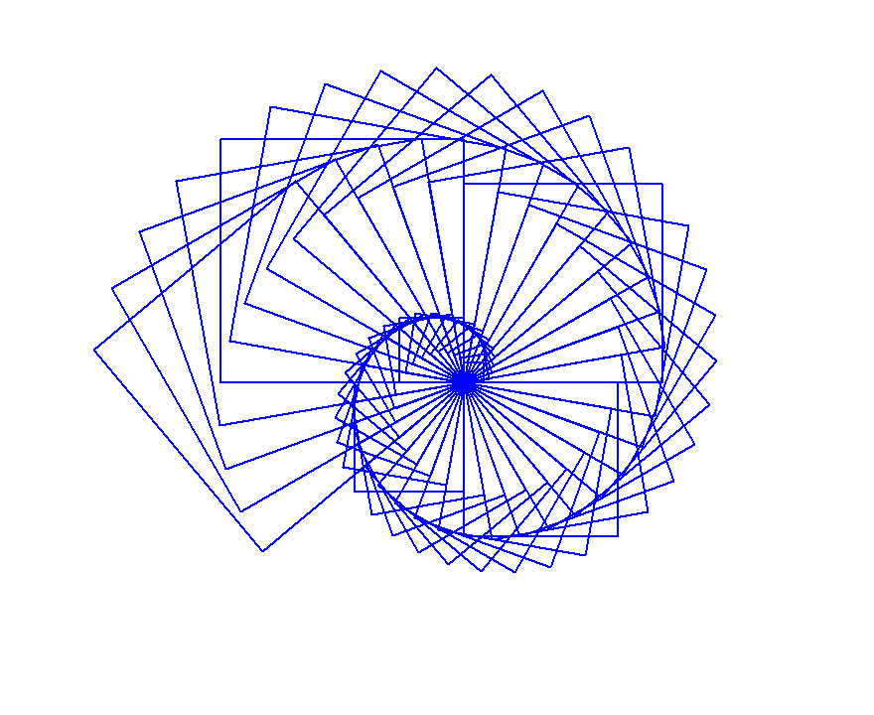

|  |  |
| --- | --- |
|  | ***Serious exercises*** |

**Exercise 1**: Write a program to standardise user’s name:



**Exercise 2**: Write a program to ask user to enter their balance then standardise it:

